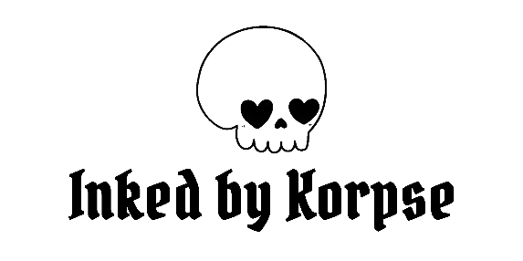

**Tattoo Consent Form**

I acknowledge by signing this agreement that I have been given the full opportunity to ask any and all questions which I might have about the obtaining of a tattoo and that all of my questions have been answered to my full satisfaction. I specifically acknowledge I have been advised of the facts and matters set forth below and I agree as follows:

* If I have diabetes, epilepsy, hepatitis, haemophilia, HIV-AIDS or any other communicable disease, heart condition or take medicine which thins the blood I have advised my tattooer. I am not pregnant or nursing. I am not under the influence of alcohol or drugs.
* I do not have medical or skin conditions such as but not limited to: acne, scarring (Keloid) eczema, psoriasis, freckles, moles or sunburn in the area to be tattooed that may interfere with said tattoo.
* I acknowledge it is not reasonably possible for the representatives and employees of ***Inked by Korpse*** to determine whether I might have an allergic reaction to the pigments or processes used in my tattoo, and I agree to accept the risk that such a reaction is possible.
* I acknowledge that infection is always possible as a result of the obtaining of a tattoo, particularly in the event that I do not take proper care of my tattoo. I have received aftercare instructions, and I agree to follow them while my tattoo is healing. I agree that any touch-up work needed, due to my own negligence, will be done at my own expense.
* I realize that variations in colour and design may exist between any tattoo as selected by me and as ultimately applied to my body. I understand that if my skin colour is dark, the colours will not appear as bright as they do on light skin.
* I understand that if I have any skin treatments, laser hair removal, plastic surgery or other skin altering procedures, it may result in adverse changes to my tattoo.
* I acknowledge that a tattoo is a permanent change to my appearance and that no representations have been made to me as to the ability to later change or remove my tattoo. To my knowledge, I do not have a physical, mental or medical impairment or disability which might affect my wellbeing as a direct or indirect result of my decision to have a tattoo.
* I acknowledge I am over the age of eighteen and that I have truthfully represented to my tattooer that the obtaining of a tattoo is by my choice alone. I consent to the application of the tattoo and to any actions or conduct of the representatives and employees of the tattoo shop reasonably necessary to perform the tattoo procedure.
* I fully understand **THE TATTOO ARTIST DOES NOT ACT AS A MEDICAL PROFESSIONAL**. Any suggestions made to me are NOT to be construed as or substituted for advice from a medical professional.

**SIGN HERE**

Full Name: ______________________________________________________ D.O.B: ___/___/______

Email: _______________________________________________ Mobile No: _____________________

Client Signature: Sign Date: ___/___/______